SAF replacement proposal.

To build a Java based in-house distributed real-time calculation framework that can form a direct replacement to Sonaris SAF framework & our existing in-house SAF Controller, while avoiding the need to re-write the entire pricing library.

Introduction

This is a short paper on my homebrew design for a SAF replacement calculation engine. It should be noted that I have designed and built this system without any internal group design sessions, so it may or may not be the solution that we would have built as a group, however it has provided a test-bed to test and flesh out various design concepts.

I plan to make this available as an open-source project on GitHub and hopefully it will be of use to Commerzbank in the future.

Architecture Overview.

This is a very high level overview of what I have actually built as a working proof of concept. While it is not an exact drop in replacement for the SAF at an API level, it has the same design concepts as SAF, and has a semantically similar API, if simpler. There are some major differences between this system and SAF, however these are contained in the implementation details and not generally exposed to the external user with the exception of the way that the graph is wired – more below.

Concepts
Conceptually the system hosts a logical graph of real-time pricing calculations mapped on a physical system with a large horizontal scaling capability.

- Each node on the logical graph is represented by a calculation package that is injected as a meta-data bundle through the controller interface to the containers.
- All sections of the logical graph must live under a mount point.
- Mount points are hosted in containers.
- All mutable operations on the graph are routed to and executed by the host container.
- Calculation package meta-data bundles are persisted to the internal database so start-up of each container is independent, standalone and fast.
- Events are the means of communication between graph nodes.
- Calculation packages accept zero-many named and typed input events, and produce zero or one named output event.
- Events are distributed between containers through one or more hubs via fast socket based pipelines.
- Events are ‘named’ and automatically wired between calculation packages by the framework.
  - NOTE: This is a radical difference to SAF. It facilitates a cleaner API and will make the interaction component (e.g. sonaris.jar) a lot simpler.
- Events and calculation packages can be introspected over controller interface.

Components
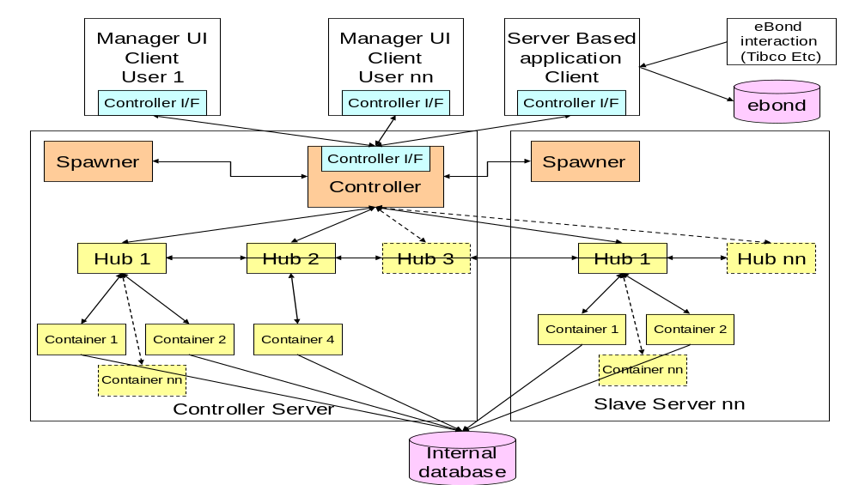

Deployment
- The system needs its own database, preferably located very close, if not on one of the machines in the ‘cluster’
- Orange items are deployed & run on standard Linux servers using our standard deployment mechanisms.
  - Each machine has to have the spawner running as a daemon service.
  - One machine deploys the controller will be the machine that the remote client’s connect to to use the API’s
- Yellow topology nodes are distinct JVM instances that are created on demand by the controller via the spawner.
- Topology structure is maintained by using the blue controller interface.
- The UI Manager client uses the controller interface to interact with the system visually.
  - i.e. maintaining topology, maintaining calculations packages, stats, logging, introspection Etc.
- A Server Based client will use the controller interface to bridge business changes into the system.

Modules
Module | Notes
client-api | The Complete configuration for any user of the API
client-cl | Used for testing 3rd party access to the API – built on client-api
client-ui | UI components – built on client-api
common | Build, settings, ivy Etc – modelled around eBond components build to make integration simple.
comms | RPC Framework & Pipeline framework
container
controller
controller-client-api
controller-container-api
controller-hub-api
controller-spawned-api
hub
msg-common | The meta-data bundles that can be built into a graph.
spawned-common | Common code for any modules that are spawnable
spawner | The daemon service that can spawn JVM components.
spawner-controller-api
util-common | Various utilities that can be used anywhere in the project

Deployable Components

Component | Contained Modules
ClientAPI | calculation-client-api-1.0.jar  calculation-comms-1.0.jar  calculation-controller-client-api-1.0.jar  calculation-msg-common-1.0.jar  calculation-util-common-1.0.jar
ClientUI | calculation-client-api-1.0.jar  calculation-client-ui-1.0.jar  calculation-comms-1.0.jar  calculation-controller-client-api-1.0.jar  calculation-msg-common-1.0.jar  calculation-util-common-1.0.jar
Controller | calculation-comms-1.0.jar  calculation-controller-1.0.jar  calculation-controller-client-api-1.0.jar  calculation-controller-container-api-1.0.jar  calculation-controller-hub-api-1.0.jar  calculation-controller-spawned-api-1.0.jar  calculation-msg-common-1.0.jar  calculation-spawner-controller-api-1.0.jar  calculation-util-common-1.0.jar
Spawner | calculation-comms-1.0.jar  calculation-spawner-1.0.jar  calculation-spawner-controller-api-1.0.jar  calculation-util-common-1.0.jar
Hub | calculation-comms-1.0.jar  calculation-controller-hub-api-1.0.jar  calculation-controller-spawned-api-1.0.jar  calculation-hub-1.0.jar  calculation-msg-common-1.0.jar  calculation-spawned-common-1.0.jar  calculation-util-common-1.0.jar
Container | calculation-comms-1.0.jar  calculation-container-1.0.jar  calculation-controller-container-api-1.0.jar  calculation-controller-spawned-api-1.0.jar  calculation-msg-common-1.0.jar  calculation-spawned-common-1.0.jar  calculation-util-common-1.0.jar

Technical Stack
- Java 1.7_04
- Spring 3.1.1 - Core / AOP / ORM / JDBC / Security
- Hessian 4.07
- Disruptor 2.7
- Swing
- Log4j
- Data: Postgres / Hibernate / Spring. (Can simply switch to use any RDBMS dialect)
- Testing: jUnit, jMock, Grinder

Task Backlog

Build the SAF replacement framework.

Task | Estimate | Notes
Analysis of requirements for the emulation of the SAF framework. |  | The SAF framework does a lot of things like hot deployment and failure detection at a container and machine level that we do not currently use as we have a Live - DR setup at the whole installation level.
Agree and document architecture outline, based on my proof of concept, and the requirements analysis. |  | The rest of the estimates are based on the architecture outlined at the end of this document.
Build / wrap an RPC framework. |  | This is for all non time critical communications. It should be interface based, automatic (reflection based) simple to modify the interface, robust enough to cope with dis-connections, and able to support a variety of client and server service styles. (singleton / one per connection / spring factory Etc.)
Build / wrap a fast message pipeline framework. |  | This is to pass events around the system. Needs to be socket based, fast and have very terse socket protocol. (In tests I have achieved a sustained in-machine round trip of sub 250microseconds (1/4 millisecond))
Build Hibernate based topology DAO / Service |  | Machine / Hub / Container / Mount
Build Hibernate based graph DAO / Service |  | Graph location, type, inputs, output.
Build the Process Spawner |  | Simple stand alone daemon process that spawns Hub and Container processes.
Build Controller / Controller Interface |  | The container manages API connections to the outside world, and routes the API calls to the correct hub / container. The container is responsible for persisting the topology meta data, and then maintaining the actual topology across all connected machines (via the process spawner)  The container is responsible for routing updates back to the API connections that register interest.
Build Hub / Hub interface |  | The hub is at the core of the event advertisement system.  Containers connect to the hub, and advertise their event outputs. The hub tells all other hubs. All hubs have a complete map of all event outputs.  Containers express interest in event outputs. Hubs request the source container to publish the event, and route it to the interested container.  Where the event is located in a container connected to another hub, the hub makes the same request to the other hub.
Build Container / Container Interface |  | Container creates the graph object instanced it hosts, and manages the routing of the events in and out. The container is responsible for the persistence of all its mounted graph items.
Build Controller
Build basic calculation types. |  | This is all the different calculation types. E.g. IntSum, IntAverage Etc. Etc.
Build GAL calc types
Build RMDS Producer calc type
Build RMDS Consumer calc type
Build MarketView Producer calc type
Build MarketView Producer calc type

Build the UI Manager client

Task | Estimate | Notes
Build topology tab |  | Ability to view and maintain the topology of the system. Machine / hub / container / mount
Build calculation selector tab |  | Browse and select the calculating types
Build graph tab |  | View and maintain the graph, including mount points. Load on demand. Each client has a separate interest set.
Build Graph Item viewer |  | View the source and value of each input and output
Build graphical viewer |  | Ability to show the flow of information through the system in a graphical way.

Build Integration component (sonaris.jar)

Task | Estimate | Notes
Convert
TODO – breakdown the tasks here

Steve Lake.

